LABORATORIO ARTIGIANO RETI
di ARCHETTI CARLO
Reti da Pesca – Sport – Caccia
Recinzione Impianti Sportivi
Antinfortunistica – Acquacoltura
25058 SULZANO (BS) – Via Tassano, n. 8
Tel. e Fax 030/985290 – Tel. Ab. 030/985191
Cell. 328 0562071 c.f. RCHCRL64C01F532U – P.I. 03216410179
www.retiarchetti.it – info@retiarchetti.it
www.retiarchetti.com – info@retiarchetti.com
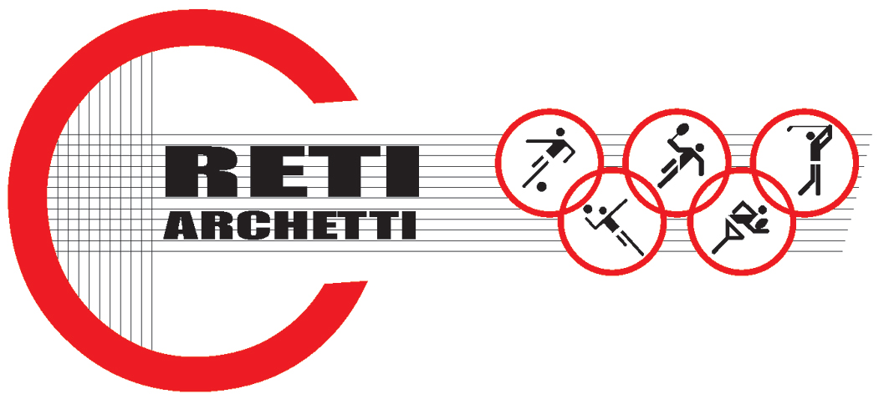

Page n. 1

TECHNICAL DATA SHEET ART.CODE: AN 1

NET MADE OF HIGH DENSITY POLYETHYLENE, KNOTTED, MESH mm 70 X 70 AND THICKNESS mm 5

STATIC TESTS: tests carried out on a polyethylene net, knotted, (braid Ø 5 mm circa and mesh mm 70) according to Standard EN 1263-1.
Hereafter the results obtained with tests on samples of a brand new net, dimensions 3 x m:

AVERAGE ULTIMATE STRENGTH: 2493 daN

Technical features

- MATERIAL: H.D. Polyethylene, stabilized against UV rays, water repellent.
- COLOR: red or blue
- BRAID: Ø 5 mm, manufactured with 16 spindles + internal core (Titrage dtax)
- NET: squared mesh, knotted and thermo fixed.
- MESH: mm 70 x 70 (according to Standard EN 1263-1 A2 – M100 – Q).
- EDGE STRIP: with a nylon rope with ultimate strength min.30 Kn
- WEIGHT: g. 400/sq m

LABORATORIO ARTIGIANO RETI
di ARCHETTI CARLO
Reti da Pesca – Sport – Caccia
Recinzione Impianti Sportivi
Antinfortunistica – Acquacoltura
25058 SULZANO (BS) – Via Vertine, n. 7
Tel. e Fax 030/985290 – Tel. Ab. 030/985191
Cell. 328 0562071 c.f. RCHCRL64C01F532U – P.I. 03216410179
www.retiarchetti.it – info@retiarchetti.it
www.retiarchetti.com – info@retiarchetti.com

Page n 2

TECHNICAL DATA SHEET ART.CODE: AN 1

NET MADE OF HIGH DENSITY POLYETHYLENE, KNOTTED, MESH mm 70 X 70 AND THICKNESS mm 5

MATERIAL FEATURES: POLYETHYLENE

- SPECIFIC WEIGHT: 0,95 KG/DM2
- SOFTENING TEMPERATURE: 102° C
- FUSION TEMPERATURE: 120° C
- MIN. USE TEMPERATURE: – 40° C
- WATER ABSORPTION: 0,01% - WATER REPELLENT –
- MOTH RESISTANCE = ABSOLUTE
- MOULD RESISTANCE = ABSOLUTE
- ABRASION RESISTANCE = EXCELLENT
- MINERAL ACIDS = RESISTANT
- ORGANIC ACIDS = RESISTANT
- BLEACHING SOLUTIONS = DAMAGED
- ALKALI = RESISTANT
- OIL = RESISTANT
- ORGANIC SOLVENTS = DAMAGED

All nets dimensions can be supplied on customer’s request, complete of their certification according to the EC standards EN 1263-1 and EN 1263-2. Nets are complete with a reinforced strip along the edge, eyelets at the angles for the hooking and the instruction manual for the installation.

